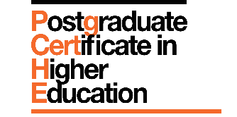

Personal Statement

As part of the recruitment process, all applicants are required to complete a personal statement. This statement will be used to determine offers of a place on the programme.
Using this template, please answer questions 1-4 below. You should write between 500 and 750 words in total.
Please also confirm that you will have a minimum of 15-hours of direct student contact per semester through the duration of the programme (Semester A: Sept – Jan, Semester B: Feb – July).

NAME__________________________________________
- Why do you wish to join the programme? What are your future goals and aspirations? What are you hoping to gain by enrolling on the PgCert HE?
- What is your current role in teaching and supporting learning? Please give details about the type of teaching you do, the learners you work with and any involvement in assessment and feedback.

- What previous development of your teaching practice have you undertaken?
- What do you anticipate the key challenges will be for you as a learner on the programme?

Any other comments: If there is any additional information that you would like to share with us to support your application to the programme, please enter it here (max. 250 words, not included in the personal statement wordcount).

